**Winkelarten**

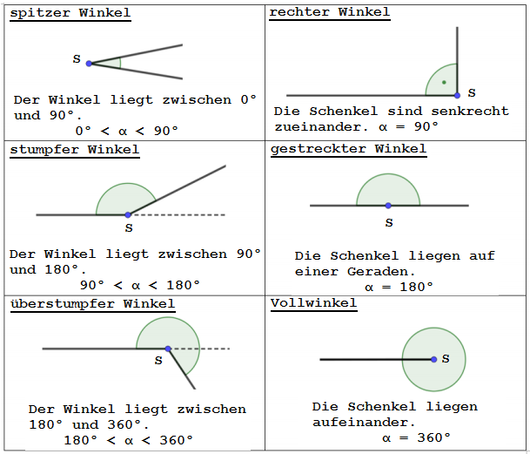

Ordne die Winkel zu.

|  |  |
| --- | --- |
| **Winkelgröße** | **Winkelart** |
| **α = 360°** |  |
| **α = 90°** |  |
| **α = 179°** |  |
| **α = 235°** |  |
| **α = 180°** |  |
| **α = 35°** |  |
| **α = 135°** |  |