**Massen umrechnen**

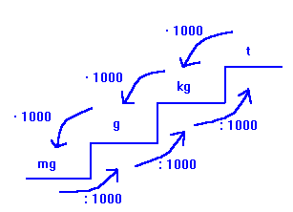

Rechne in die angegebene Einheit um.

1) 1447 mg = __________________ t

2) 2403 t = __________________ g

3) 3,444 g = __________________ kg

4) 18,68 t = __________________ kg

5) 0,1932 g = __________________ t

6) 310 mg = __________________ kg

7) 341 g = __________________ mg

8) 0,5416 kg = __________________ t

9) 4705 kg = __________________ mg

10) 0,2868 kg = __________________ t

11) 3816 t = __________________ mg

12) 5305 g = __________________ t

13) 5502 mg = __________________ t

14) 84,03 t = __________________ mg

15) 2,316 g = __________________ t